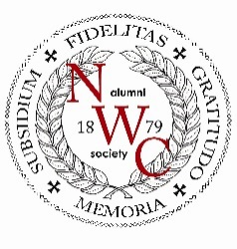
Northwestern College Alumni Society Giving Form

Amount:

Annual Gift: _______________ ($25.00)

President’s Fund: _______________

150th Anniversary Projects: _______________

Total: _______________

Recurrence:  One-time

Recurring: Monthly Quarterly Semi-annually Annually

Payment method:
  
   Check Make payable to Wisconsin Lutheran Seminary and mail with this form to:
Northwestern College Alumni Society
c/o Wisconsin Lutheran Seminary
11831 N Seminary Drive
Mequon, WI 53092

❑ Credit card #______________________________ Exp: ___________ Taken on the 15th.

   Electronic Funds Transfer Please enclose a voided check. Taken on the 15th.

Personal information:

Name: _____________________________ Address: __________________________________________

City: ______________________ State: _______ ZIP: ____________ E-mail: ________________________

Phone: ____________________ Congregation (include city, state) _______________________________

Thank you!

Alan H. Siggelkow, President
NWC Alumni Society
Graduating Class of 1965

